

**PC-CENTRE**

**E-Project Documentation**

**Teacher Name: Miss Mahnoor Tahir**

**APTECH COMPUTER EDUCATION**

**HYDERABAD-1 PAKISTAN**

**Issue Date: 17-sep-24**

TABLE OF CONTENT

|  |  |  |
| --- | --- | --- |
| **S No** | **Contents** | **Page No** |
| 01 | Certificate | 3 |
| 02 | Acknowledgement | 4 |
| 03 | Project Report | 5 |
| 04 | Problem Definition | 6 |
| 05 | Customer Requirements Specification  (CRS) | 7 |
| 06 | Architecture Design of the Project | 8 |
| 07 | System Requirement | 9 |
| 08 | Task Sheet | 10 |
| 09 | Project Plan | 11 |
| 10 | Checklist of work Progress | 12 |
| 11 | Final Check List | 13 |
| 12 | Screen Shots | 14 |
| 13 | Source Code | 16 |

CERTIFICATE

This is to certify that

**KHUSHBOO JAMALI, DUA ARSHAD, SUMAIMA SOHAIL, FATIMA SEHAR, KINZA KHAN**

Submitted by:

**ALL GROUP MEMBERS**

Has successfully Designed

ONLINE SHOPPING-CART

Date of Issue: **17-sep-24**

Authorized Signature: Miss Mahnoor Tahir

ACKNOWLEDGEMENT

First and foremost, we would like to express our deep gratitude and most heartfelt thanks to almighty ALLAH for his blessings, for lightening up our heart with the torch of knowledge and for giving us the ability to complete this project.

We would like to thanks Aptech Worldwide and the team of E-Project for their generous support and clarifying the doubts regarding e-project. We would like to acknowledge the way of explanation which the team of e-project gave in e-project to make website and we are equally grateful to our teacher (Miss Mahnoor) for giving us a moral support and guiding us different matters regarding project in all the time about the research and writing of this project.

We are greatly indebted to Aptech Worldwide, Miss Mahnoor, Faculty Members and ACE Hyderabad, Pakistan for encouragement and incessant help.

PROJECT REPORT

**BY:**

**Student1526929 KHUSHBOO JAMALI.**

**Student1526936 DUA ARSHAD.**

**Student1526935 SUMAIMA SOHAIL**

**Student1526925 FATIMA SEHAR**

**Student1534840 KINZA KHAN**

Project Title: ONLINESHOPPING-CART

Members Name: Khushboo Jamali, Dua Arshad, Sumaima Sohail, Fatima Sehar, Kinza khan

Batch Code: 2310f

Start Date: 17-sep -2024

End Date: 14-oct -2024

Course: DISM

Teacher: Miss Mahnoor Tahir

Center Manager: Sir Shoaib Ahmed

Center Academic Head: Sir Zubair

Center Name: ACE Hyderabad-1, Pakistan

Submitted as

E Project Documentation

**PROBLEM STATEMENT**

PC-Centre is a provider of IT products and services in and around the city. With over 2 years experience and a portfolio of over 1,000 products from many leading, manufacturers, they are an independent supplier, offering great deals and best pricing on variety of items, from a massive selection of top brands. Their product range includes hardware, software, peripherals, networking, communications, media, supplies and accessories etc.

In addition, PC-Centre offers home PC installations for consumers and various complementary IT solutions for business including high end enterprise solutions aimed at keeping infrastructures running smoothly.

Post Sales support is the most important aspect of business and they aim to exceed customer’s expectations with a superior level of after-sales technical and customer services. They provide a strong team of qualified Technical Support and Customer Service Advisors to offer advice, assistance and support for any products and solutions purchased from PC-centre..

Functional Requirement:

A home page with menu that categorizes all the functions of the site.

Sample screen shot of home page is shown below.

1. Maintaining the details of the Employees, product details, stock details, order, and delivery details of the products and that of the customers are to be maintained with the help of the database.
2. There should be separate login for Admin, Employees and for the customer.

Architecture & Design of the Project:

Since the website will have client architecture it will have one-tier architecture.

System Requirement:

|  |  |  |
| --- | --- | --- |
| **SR.No** | **Items** | **Description** |
| 01 | Operating System | Window XP, Win7 or win8 |
| 02 | Main Processor | Minimum 2ghz or better |
| 03 | Ram (Memory) | Minimum 512mb or better |
| 04 | Web Browser | Google Chrome or Firefox (Latest) |
| 05 | Software | Notepad, HTML editor, Adobe Dreamweaver CS5.5 |

TASK SHEET

|  |  |  |  |  |  |
| --- | --- | --- | --- | --- | --- |
| **Project Ref. No:** | | **Date of Preparation of Activity Plan:** | | | |
| Sr.no | Task | Actual  Start Date: | Actual  Day: | Team  Mates Names: | Status: |
| 01 | Meeting | 17 sep, 2024 | 2 | Khushboo Jamali, Dua Arshad, Sumaima Sohail, Fatima Sehar, Kinza khan |  |
| 02 | Data  Collection | 19 sep, 2024 | 1 | Khushboo Jamali, Dua Arshad, Sumaima Sohail, Fatima Sehar, Kinza khan |  |
| 03 | Designing  Home  Page | 20 sep, 2024 | 2 | Khushboo Jamali, Dua Arshad, Sumaima Sohail, Fatima Sehar, Kinza khan |  |
| 04 | Linking | 22 sep, 2024 | 5 | Khushboo Jamali, Dua Arshad, Sumaima Sohail, Fatima Sehar, Kinza khan |  |
| 05 | Check  Links | 27 sep, 2024 | 2 | Khushboo Jamali, Dua Arshad, Sumaima Sohail, Fatima Sehar, Kinza khan |  |
| 06 | Designing Menu Page | 29 sep, 2024 | 2 | Khushboo Jamali, Dua Arshad, Sumaima Sohail, Fatima Sehar, Kinza khan |  |
| 07 | Designing Other Pages | 1 oct, 2024 | 10 | Khushboo Jamali, Dua Arshad, Sumaima Sohail, Fatima Sehar, Kinza khan |  |
| 06 | Finalizing | 10 oct, 2024 | 2 | Khushboo Jamali, Dua Arshad, Sumaima Sohail, Fatima Sehar, Kinza khan |  |
| 08 | Documentation | 12 oct, 2024 | 2 | Khushboo Jamali, Dua Arshad, Sumaima Sohail, Fatima Sehar, Kinza khan |  |
| 09 | Uploading | 14 oct, 2024 | 1 | Khushboo Jamali, Dua Arshad, Sumaima Sohail, Fatima Sehar, Kinza khan |  |

PROJECT PLAN

* Website is able to execute quickly.
* The color combination of our website is so attractive.
* The collection of data is authentic and taken by the most popular product websites.
* Background of each page is as same as the main page.
* The contact page is well prepared exactly for the same page as user clicks on the link...
* A user can resolve its difficulties easily from this site.

CHECK LIST OF WORK PROGRESS

|  |  |  |
| --- | --- | --- |
| **SR. No** | **Aspect Tested** | **Remarks** |
| 01 | Data Collection |  |
| 02 | Designing Home Page |  |
| 03 | Linking The Pages |  |
| 04 | Designing Other Pages |  |
| 05 | Finalization |  |
| 06 | Documentation |  |

FINAL CHECK LIST

|  |  |  |  |
| --- | --- | --- | --- |
| **SR.No** | **Particulars** | **Yes** | **No** |
| 01 | Do all pages open? | YES |  |
| 02 | Are all hyperlinks working? | YES |  |
| 03 | Are the web page contents devoid for  spelling mistakes? |  | No |
| 04 | Are all the web components working? | YES |  |
| 05 | Is site browser compatible? | YES |  |

SCREEN SHOTS:

DATA BASE

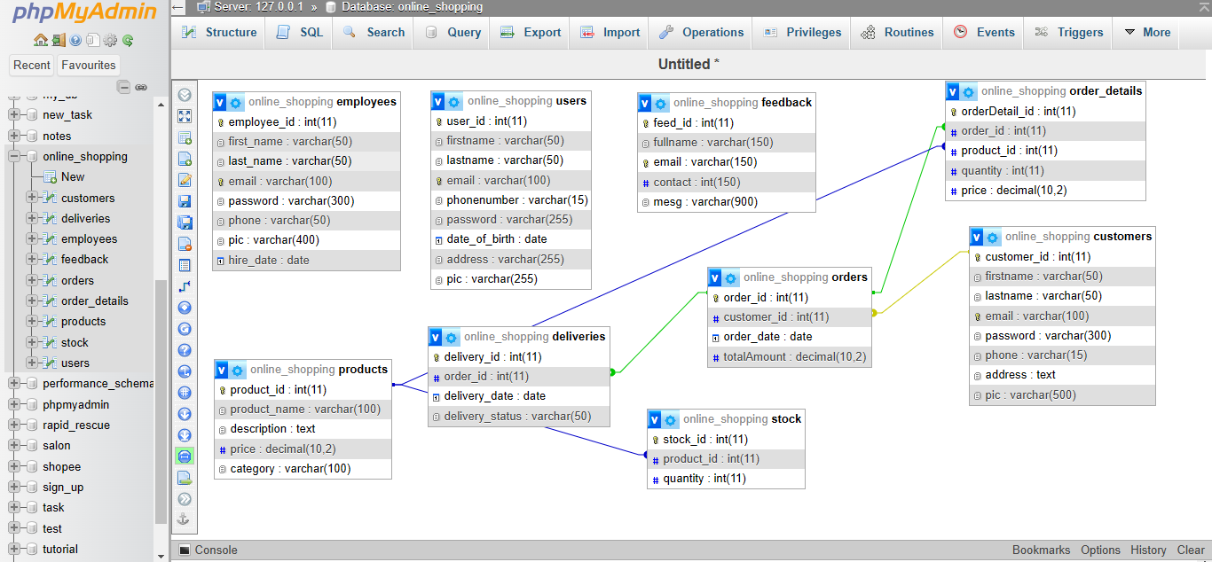

HOME PAGE

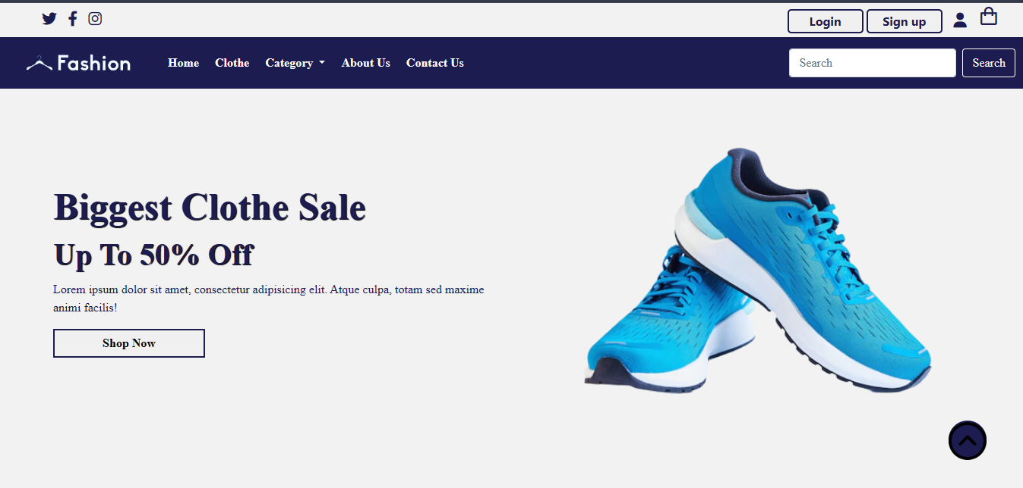

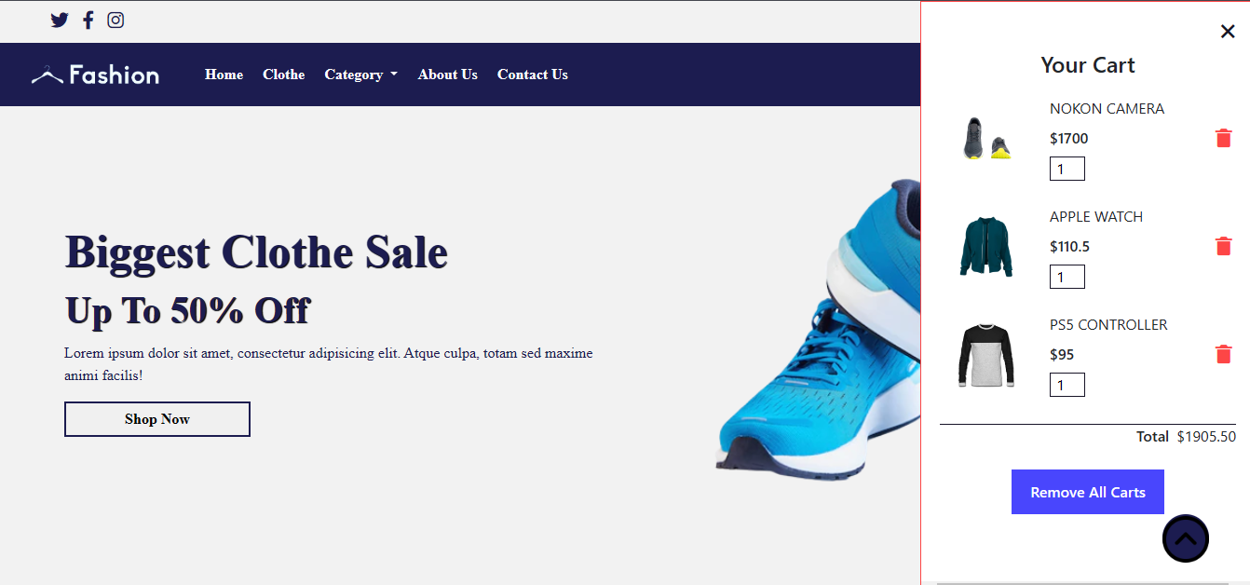

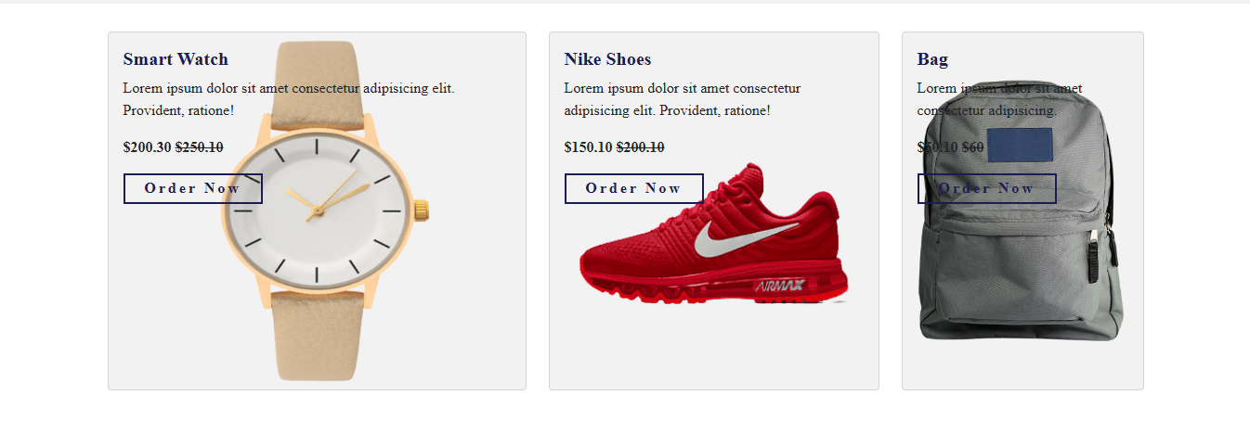

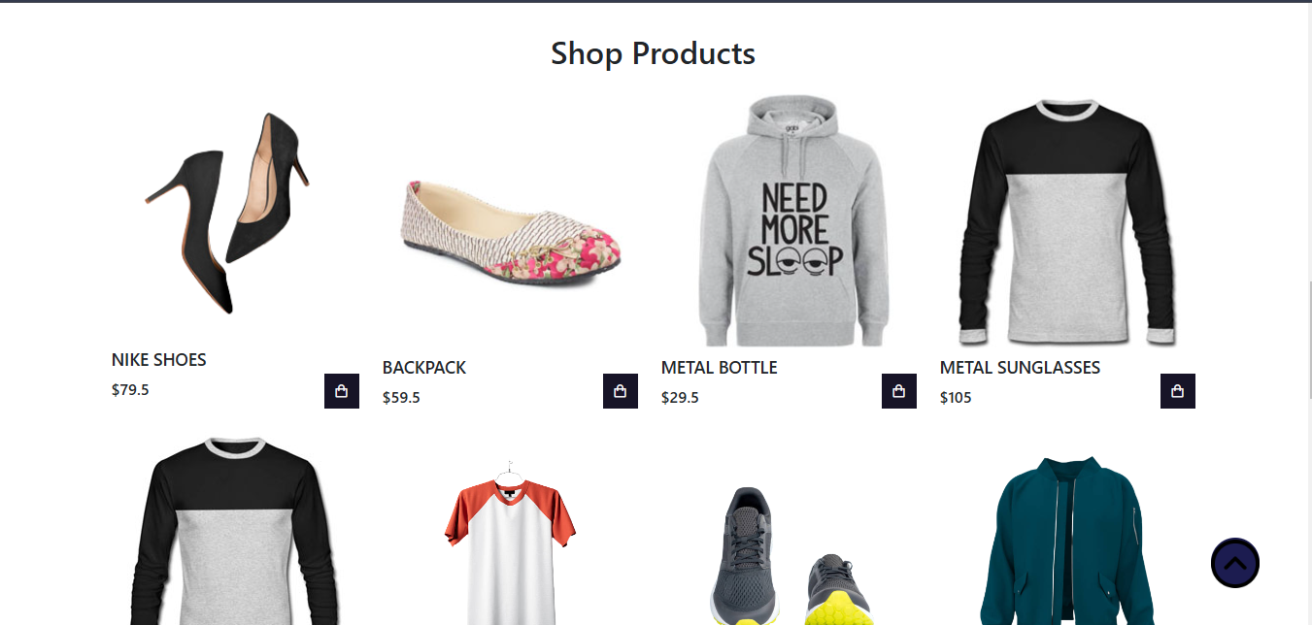

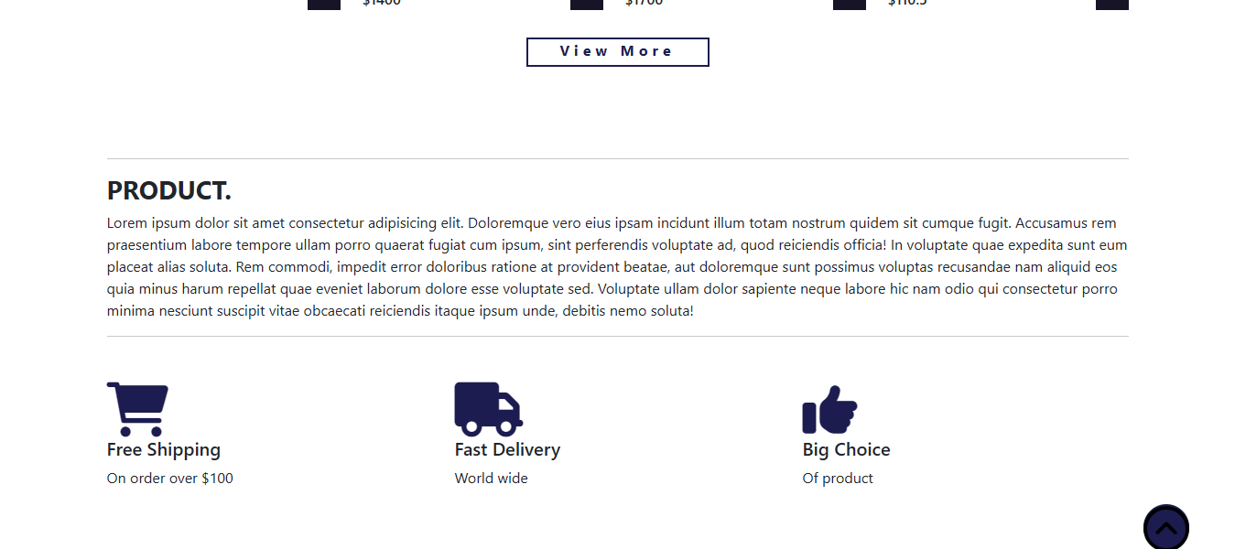

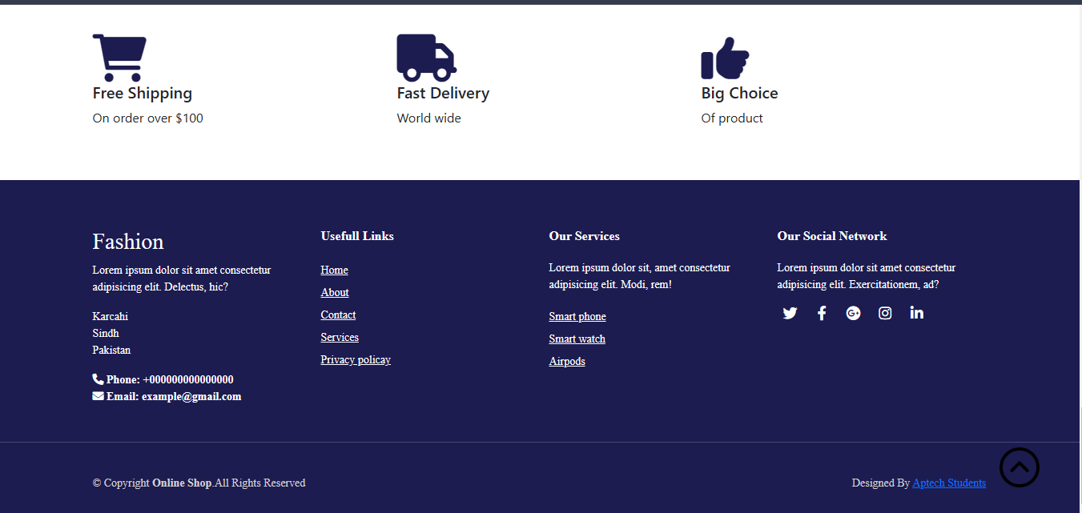

CLOTH OR PRODUCT

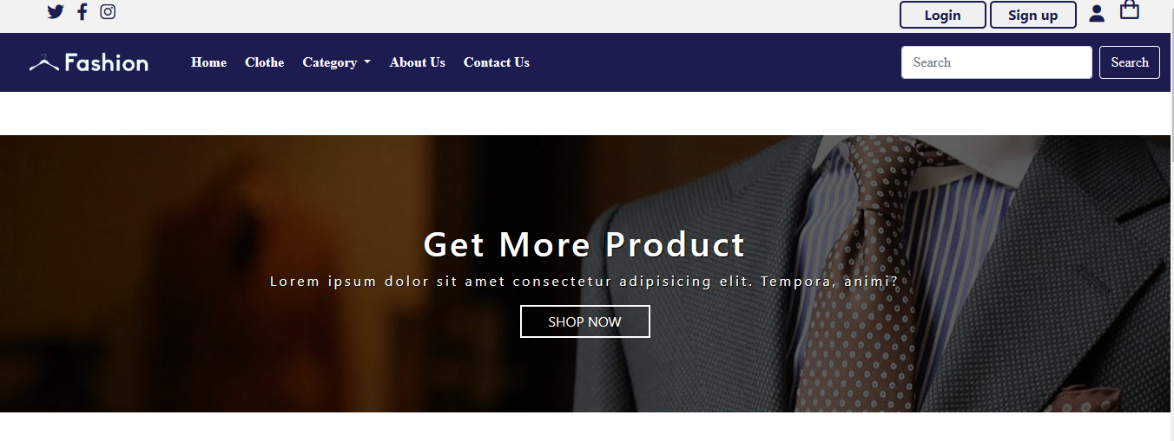

ABOUT US

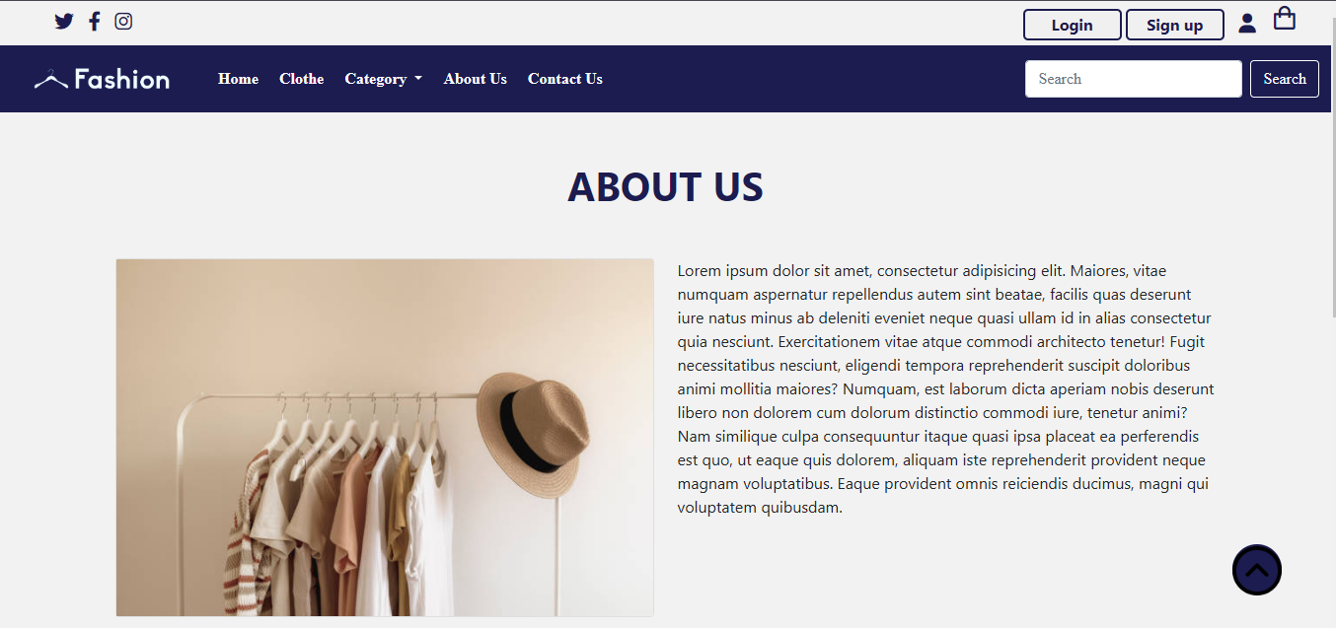

CONTACT

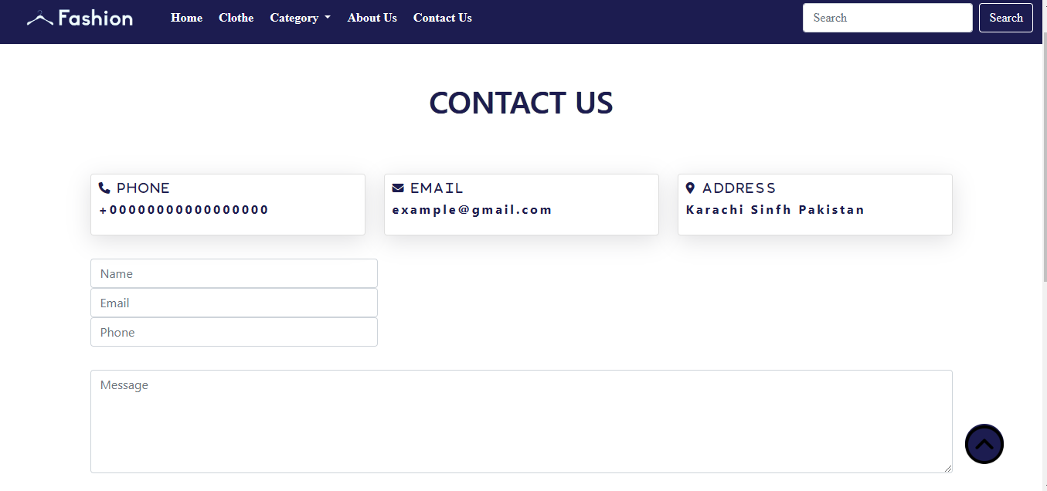

LOGIN & SIGNUP

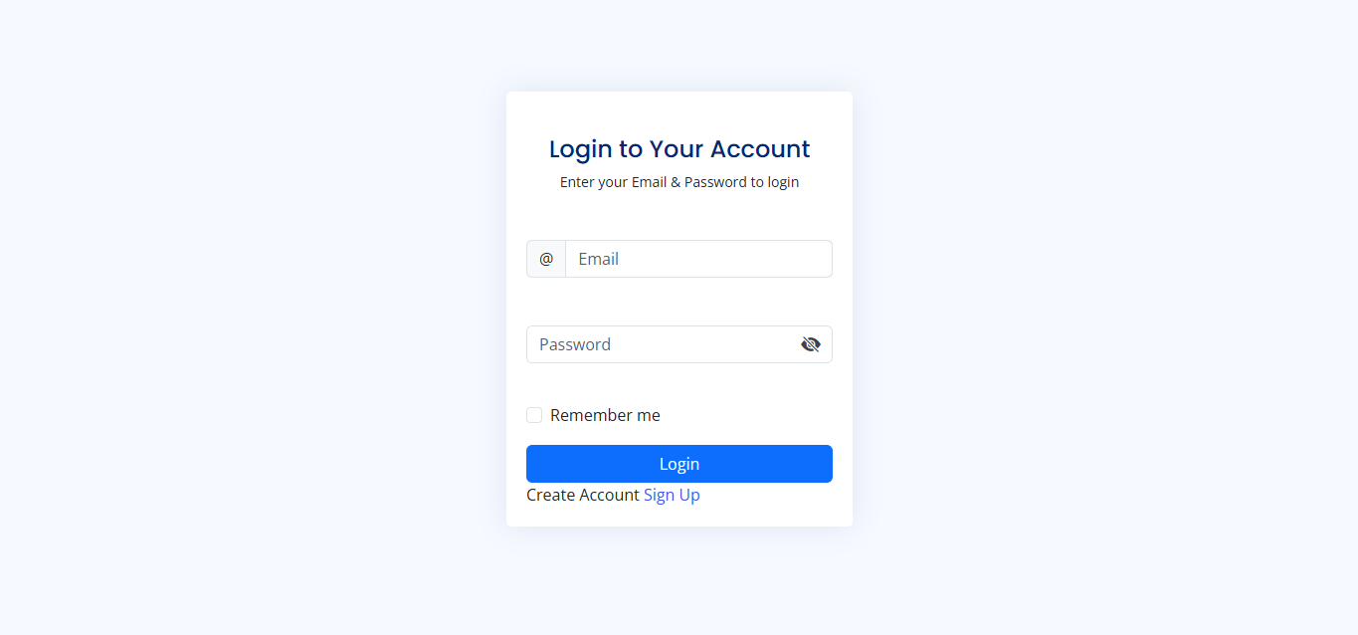

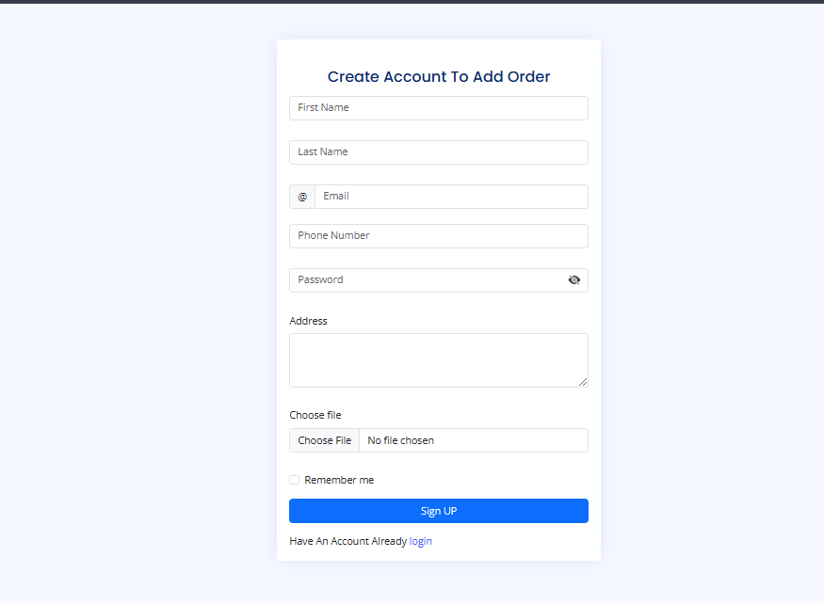

USER DASHBOARD

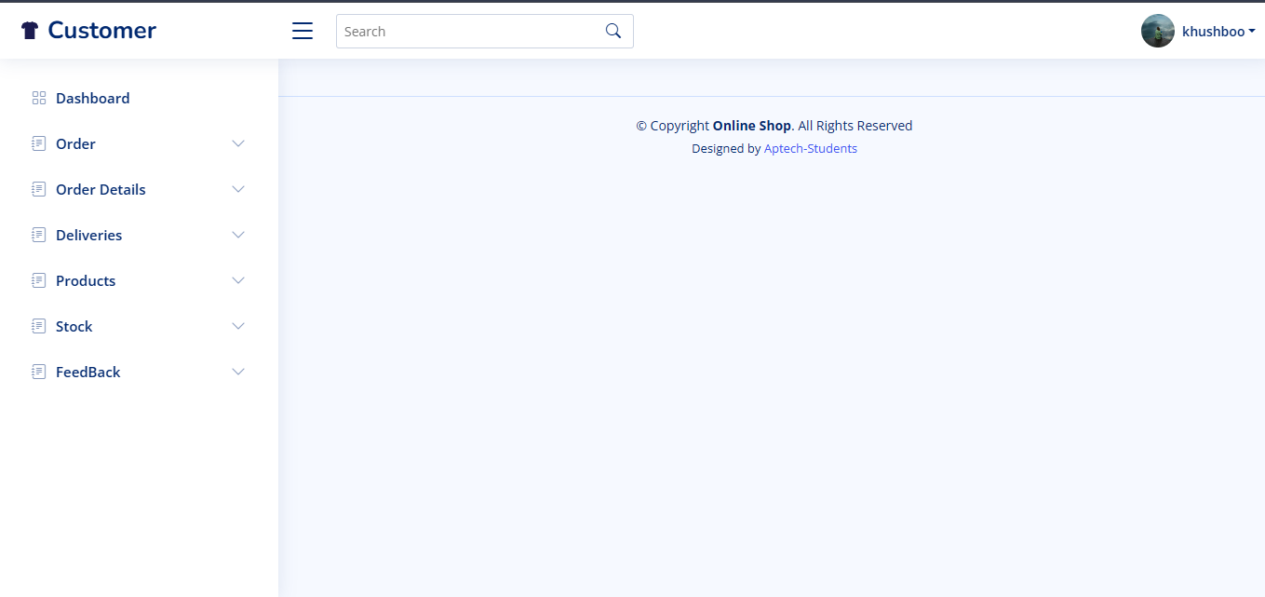

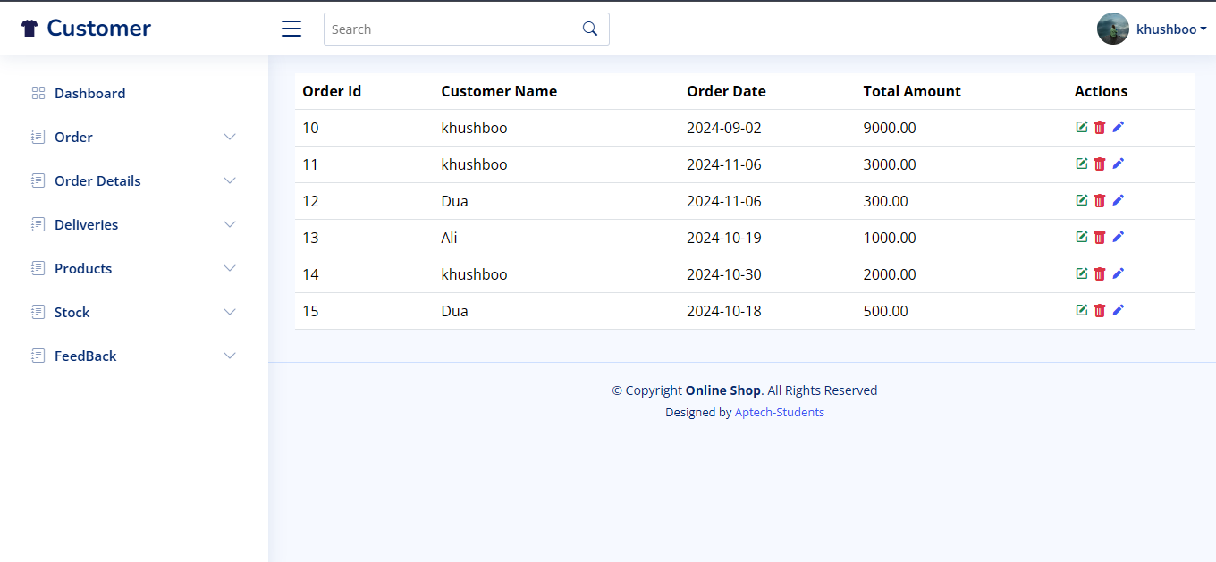

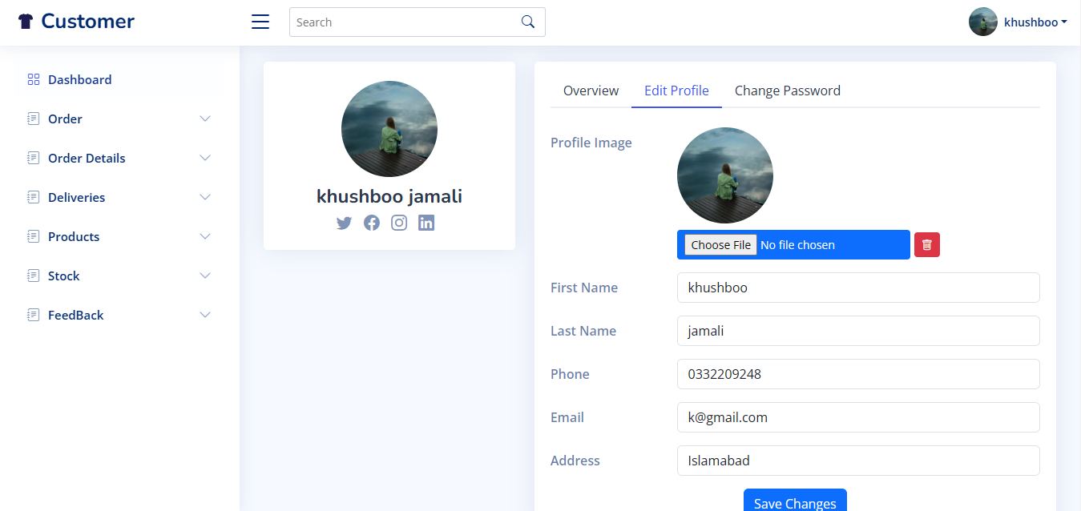

SOURCE CODE:

<!DOCTYPE html>

<html lang="en">

<head>

  <meta charset="UTF-8" />

  <meta http-equiv="X-UA-Compatible" content="IE=edge" />

  <meta name="viewport" content="width=device-width, initial-scale=1.0" />

  <title>Fashion</title>

  <link rel="shortcut icon" type="image" href="./image/logo2.png" />

  <link rel="stylesheet" href="style.css" />

  <link

    rel="stylesheet"

    href="https://cdnjs.cloudflare.com/ajax/libs/font-awesome/6.2.0/css/all.min.css" />

  <!-- bootstrap links -->

  <link

    href="https://cdn.jsdelivr.net/npm/bootstrap@5.0.2/dist/css/bootstrap.min.css"

    rel="stylesheet"

    integrity="sha384-EVSTQN3/azprG1Anm3QDgpJLIm9Nao0Yz1ztcQTwFspd3yD65VohhpuuCOmLASjC"

    crossorigin="anonymous" />

  <!-- bootstrap links -->

  <!-- fonts links -->

  <link

    href="https://unpkg.com/boxicons@2.1.2/css/boxicons.min.css"

    rel="stylesheet" />

  <!-- styles  -->

  <link rel="preconnect" href="https://fonts.googleapis.com" />

  <link rel="preconnect" href="https://fonts.gstatic.com" crossorigin />

  <link

    href="https://fonts.googleapis.com/css2?family=Roboto:wght@500&display=swap"

    rel="stylesheet" />

  <!-- fonts links -->

</head>

<style>

  /* CSS Reset */

  * {

    margin: 0;

    padding: 0;

    box-sizing: border-box;

  }

  body {

    overflow-x: hidden;

    /* Prevent horizontal scrolling */

  }

  :root {

    --main-color: #fd4646;

    --sec-color: #4946fd;

    --text-color: #171427;

    --bg-color: #fff;

  }

  /* Add your existing CSS styles here */

  #cart-icon {

    font-size: 1.8rem;

    cursor: pointer;

  }

  /* CART  */

  .cart {

    position: absolute;

    top: 0;

    right: -100%;

    width: 360px;

    height: 100vh;

    overflow-y: auto;

    padding: 20px;

    background-color: var(--bg-color);

    box-shadow: -2px solid 4px hsl(0 4% 15% / 10%);

    border: 1px solid var(--main-color);

    transition: 1.5s;

  }

  .order-btn {

    display: flex;

    margin: 1.5rem auto 0 auto;

    padding: 12px 20px;

    border: none;

    background-color: var(--sec-color);

    color: var(--bg-color);

    font-size: 1rem;

    font-weight: 500;

    cursor: pointer;

  }

  .cart.active {

    right: 0;

    transition: 0.5s;

  }

  .cart-title {

    text-align: center;

    font-size: 1.5rem;

    font-weight: 600;

    margin-top: 2rem;

  }

  .cart-box {

    display: grid;

    grid-template-columns: 32% 50% 18%;

    align-items: center;

    gap: 1rem;

    margin-top: 1rem;

  }

  .cart-img {

    width: 100px;

    height: 100px;

    object-fit: contain;

    padding: 10px;

  }

  .detail-box {

    display: grid;

    row-gap: 0.5rem;

  }

  .cart-product-title {

    font-size: 1rem;

    text-transform: uppercase;

  }

  .cart-price {

    font-weight: 500;

  }

  .cart-quantity {

    border: 1px solid var(--text-color);

    outline-color: var(--main-color);

    width: 2.4rem;

    text-align: center;

    font-size: 1rem;

  }

  .cart-remove {

    font-size: 24px;

    color: var(--main-color);

    cursor: pointer;

  }

  .total {

    display: flex;

    justify-content: flex-end;

    margin-top: 1.5rem;

    border-top: 1px solid var(--text-color);

  }

  .total-title {

    font-size: 1rem;

    font-weight: 600;

  }

  .total-price {

    margin-left: 0.5rem;

  }

  .btn-buy {

    display: flex;

    margin: 1.5rem auto 0 auto;

    padding: 12px 20px;

    border: none;

    background-color: var(--sec-color);

    color: var(--bg-color);

    font-size: 1rem;

    font-weight: 500;

    cursor: pointer;

  }

  .btn-buy:hover {

    background-color: var(--text-color);

  }

  #cart-close {

    position: absolute;

    top: 1rem;

    right: 0.8rem;

    font-size: 2rem;

    color: var(--text-color);

    cursor: pointer;

  }

  /* SHOP SECTION  */

  .shop {

    margin-top: 2rem;

  }

  .section-title {

    font-style: 1.5rem;

    font-weight: 600;

    text-align: center;

    margin-bottom: 1.5rem;

  }

  .shop-content {

    display: grid;

    grid-template-columns: repeat(auto-fit, minmax(220px, auto));

    gap: 1.5rem;

  }

  .product-box {

    position: relative;

  }

  .product-box:hover {

    padding: 10px;

    border: 1px solid var(--text-color);

    transition: 0.4s;

  }

  .product-img {

    width: 100%;

    aspect-ratio: 1/1;

    object-fit: cover;

    margin-bottom: 0.5rem;

  }

  .product-title {

    font-size: 1.1rem;

    font-weight: 600;

    text-transform: uppercase;

    margin-bottom: 0.5rem;

  }

  .product-price {

    font-weight: 500;

  }

  .add-cart {

    position: absolute;

    bottom: 0;

    right: 0;

    background-color: var(--text-color);

    color: var(--bg-color);

    padding: 10px;

    cursor: pointer;

  }

  .add-cart:hover {

    background-color: hsl(249, 32%, 17%);

  }

  /* SHOP SECTION  */

  .shop {

    margin-top: 2rem;

  }

  .section-title {

    font-style: 1.5rem;

    font-weight: 600;

    text-align: center;

    margin-bottom: 1.5rem;

  }

  .shop-content {

    display: grid;

    grid-template-columns: repeat(auto-fit, minmax(220px, auto));

    gap: 1.5rem;

  }

  .product-box {

    position: relative;

  }

  .product-box:hover {

    padding: 10px;

    border: 1px solid var(--text-color);

    transition: 0.4s;

  }

  .product-img {

    width: 100%;

    aspect-ratio: 1/1;

    object-fit: cover;

    margin-bottom: 0.5rem;

  }

  .product-title {

    font-size: 1.1rem;

    font-weight: 600;

    text-transform: uppercase;

    margin-bottom: 0.5rem;

  }

  .product-price {

    font-weight: 500;

  }

  .add-cart {

    position: absolute;

    bottom: 0;

    right: 0;

    background-color: var(--text-color);

    color: var(--bg-color);

    padding: 10px;

    cursor: pointer;

  }

  .add-cart:hover {

    background-color: hsl(249, 32%, 17%);

  }

  /* ================ RESPONSIVE & BREAKPOINTS ============= */

  @media (max-width: 1080px) {

    .nav {

      padding: 15px;

    }

    .container {

      width: 90%;

      margin: 0 auto;

    }

    section {

      padding: 3rem 0 2rem;

    }

    .shop {

      margin-top: 2rem;

    }

  }

  /* For Medium Devices */

  @media (max-width: 400px) {

    .nav {

      padding: 11px;

    }

    .logo {

      font-size: 1rem;

    }

    .cart {

      width: 320px;

    }

  }

  /* For Small Devices */

  @media (max-width: 360px) {

    .shop {

      margin-top: 1rem;

    }

    .cart {

      width: 280px;

    }

  }

</style>

<body>

  <!-- top navbar -->

  <div class="top-navbar">

    <div class="top-icons">

      <i class="fa-brands fa-twitter"></i>

      <i class="fa-brands fa-facebook-f"></i>

      <i class="fa-brands fa-instagram"></i>

    </div>

    <div class="other-links">

      <button id="btn-login"><a href="./customers/login.php">Login</a></button>

      <button id="btn-signup"><a href="./customers/signup.php">Sign up</a></button>

      <i class="fa-solid fa-user"></i>

      <i class="bx bx-shopping-bag" id="cart-icon"></i>

    </div>

  </div>

  <!-- top navbar -->

  <div class="home-section">

    <!-- navbar -->

    <nav class="navbar navbar-expand-lg" id="navbar">

      <div class="container-fluid">

        <a class="navbar-brand" href="#"><img src="./image/logo.png" alt="" width="180px" /></a>

        <button

          class="navbar-toggler"

          type="button"

          data-bs-toggle="collapse"

          data-bs-target="#navbarSupportedContent"

          aria-controls="navbarSupportedContent"

          aria-expanded="false"

          aria-label="Toggle navigation">

          <span><i class="fa-solid fa-bars" style="color: white"></i></span>

        </button>

        <div class="collapse navbar-collapse" id="navbarSupportedContent">

          <ul class="navbar-nav me-auto mb-2 mb-lg-0">

            <li class="nav-item">

              <a class="nav-link active" aria-current="page" href="index.php">Home</a>

            </li>

            <li class="nav-item">

              <a class="nav-link" href="clothe.php">Clothe</a>

            </li>

            <li class="nav-item dropdown">

              <a

                class="nav-link dropdown-toggle"

                href="#"

                id="navbarDropdown"

                role="button"

                data-bs-toggle="dropdown"

                aria-expanded="false">

                Category

              </a>

              <ul

                class="dropdown-menu"

                aria-labelledby="navbarDropdown"

                style="background-color: #1c1c50">

                <li><a class="dropdown-item" href="clothe.php">T-Shirt</a></li>

                <li><a class="dropdown-item" href="clothe.php">Hoodies</a></li>

                <li><a class="dropdown-item" href="clothe.php">Pants</a></li>

              </ul>

            </li>

            <li class="nav-item">

              <a class="nav-link" href="about.php">About Us</a>

            </li>

            <li class="nav-item">

              <a class="nav-link" href="contact.php">Contact Us</a>

            </li>

          </ul>

          <form class="d-flex">

            <input

              class="form-control me-2"

              type="search"

              placeholder="Search"

              aria-label="Search" />

            <button

              class="btn btn-outline-success"

              type="submit"

              id="search-btn">

              Search

            </button>

          </form>

        </div>

      </div>

    </nav>

    <!-- navbar -->

    <!-- home content -->

    <section class="home">

      <div class="content">

        <h3>

          Biggest Clothe Sale <br />

          <span>Up To 50% Off</span>

        </h3>

        <p>

          Lorem ipsum dolor sit amet, consectetur adipisicing elit. Atque

          culpa, totam sed maxime animi facilis!

        </p>

        <a href="./customers/login.php">

          <button id="shopnow">Shop Now</button>

        </a>

      </div>

      <div class="img">

        <img src="./image/b2.png" alt="" />

      </div>

    </section>

    <!-- home content -->

  </div>

  <!-- top cards -->

  <div class="container" id="top-cards">

    <div class="row">

      <div class="col-md-5 py-3 py-md-0">

        <div class="card" style="background-color: #a9a9a926">

          <img src="./image/topcard1.png" alt="" />

          <div class="card-img-overlay">

            <h5 class="card-titel">Smart Watch</h5>

            <p>

              Lorem ipsum dolor sit amet consectetur adipisicing elit.

              Provident, ratione!

            </p>

            <p>

              <strong>$200.30 <strike>$250.10</strike></strong>

            </p>

            <button>Order Now</button>

          </div>

        </div>

      </div>

      <div class="col-md-4 py-3 py-md-0">

        <div class="card" style="background-color: #a9a9a926">

          <img src="./image/topcard2.png" alt="" />

          <div class="card-img-overlay">

            <h5 class="card-titel">Nike Shoes</h5>

            <p>

              Lorem ipsum dolor sit amet consectetur adipisicing elit.

              Provident, ratione!

            </p>

            <p>

              <strong>$150.10 <strike>$200.10</strike></strong>

            </p>

            <button>Order Now</button>

          </div>

        </div>

      </div>

      <div class="col-md-3 py-3 py-md-0">

        <div class="card" style="background-color: #a9a9a926">

          <img src="./image/topcard3.png" alt="" />

          <div class="card-img-overlay">

            <h5 class="card-titel">Bag</h5>

            <p>Lorem ipsum dolor sit amet consectetur adipisicing.</p>

            <p>

              <strong>$50.10 <strike>$60</strike></strong>

            </p>

            <button>Order Now</button>

          </div>

        </div>

      </div>

    </div>

  </div>

  <!-- top cards -->

  <!-- banner -->

  <div class="banner">

    <div class="content">

      <h1>Get Up To 50% Off</h1>

      <p>

        Lorem ipsum dolor sit amet consectetur adipisicing elit. Tempora,

        animi?

      </p>

      <div id="bannerbtn"><button>SHOP NOW</button></div>

    </div>

  </div>

  <!-- banner -->

  <!-- product cards -->

  <section class="shop container">

    <h2 class="section-title">Shop Products</h2>

    <!-- CONTENT  -->

    <div class="shop-content">

      <div class="cart">

        <h2 class="cart-title">Your Cart</h2>

        <!-- CONTENT  -->

        <div class="cart-content"></div>

        <!-- TOTAL   -->

        <div class="total">

          <div class="total-title">Total</div>

          <div class="total-price">$0</div>

        </div>

        <!-- BUY BUTTON  -->

        <button type="button" class="btn-buy">Remove All Carts</button>

        <!-- CART CLOSE  -->

        <i class="bx bx-x" id="cart-close"></i>

      </div>

      <!-- BOX 1 -->

      <div class="product-box">

        <img src="./image/p1.png" alt="" class="product-img" />

        <h2 class="product-title">Nike Shoes</h2>

        <span class="product-price">$79.5</span>

        <i class="bx bx-shopping-bag add-cart"></i>

      </div>

      <!-- BOX 2 -->

      <div class="product-box">

        <img src="./image/p10.jpg" alt="" class="product-img" />

        <h2 class="product-title">BACKPACK</h2>

        <span class="product-price">$59.5</span>

        <i class="bx bx-shopping-bag add-cart"></i>

      </div>

      <!-- BOX 3 -->

      <div class="product-box">

        <img src="./image/p11.jpg" alt="" class="product-img" />

        <h2 class="product-title">METAL BOTTLE</h2>

        <span class="product-price">$29.5</span>

        <i class="bx bx-shopping-bag add-cart"></i>

      </div>

      <!-- BOX 4 -->

      <div class="product-box">

        <img src="./image/p12.jpg" alt="" class="product-img" />

        <h2 class="product-title">METAL SUNGLASSES</h2>

        <span class="product-price">$105</span>

        <i class="bx bx-shopping-bag add-cart"></i>

      </div>

      <!-- BOX 5 -->

      <div class="product-box">

        <img src="./image/p12.jpg" alt="" class="product-img" />

        <h2 class="product-title">PS5 Controller</h2>

        <span class="product-price">$95</span>

        <i class="bx bx-shopping-bag add-cart"></i>

      </div>

      <!-- BOX 6 -->

      <div class="product-box">

        <img src="./image/p13.png" alt="" class="product-img" />

        <h2 class="product-title">Galaxy Z Fold</h2>

        <span class="product-price">$1400</span>

        <i class="bx bx-shopping-bag add-cart"></i>

      </div>

      <!-- BOX 7 -->

      <div class="product-box">

        <img src="./image/p15.png" alt="" class="product-img" />

        <h2 class="product-title">Nokon Camera</h2>

        <span class="product-price">$1700</span>

        <i class="bx bx-shopping-bag add-cart"></i>

      </div>

      <!-- BOX 8 -->

      <div class="product-box">

        <img src="./image/p16.png" alt="" class="product-img" />

        <h2 class="product-title">Apple Watch</h2>

        <span class="product-price">$110.5</span>

        <i class="bx bx-shopping-bag add-cart"></i>

      </div>

    </div>

  </section>

  <a href="clothe.php" id="viewmorebtn">View More</a>

  <!-- product cards -->

  <!-- product -->

  <div class="container" style="margin-top: 100px">

    <hr />

  </div>

  <div class="container">

    <h3 style="font-weight: bold">PRODUCT.</h3>

    <p>

      Lorem ipsum dolor sit amet consectetur adipisicing elit. Doloremque vero

      eius ipsam incidunt illum totam nostrum quidem sit cumque fugit.

      Accusamus rem praesentium labore tempore ullam porro quaerat fugiat cum

      ipsum, sint perferendis voluptate ad, quod reiciendis officia! In

      voluptate quae expedita sunt eum placeat alias soluta. Rem commodi,

      impedit error doloribus ratione at provident beatae, aut doloremque sunt

      possimus voluptas recusandae nam aliquid eos quia minus harum repellat

      quae eveniet laborum dolore esse voluptate sed. Voluptate ullam dolor

      sapiente neque labore hic nam odio qui consectetur porro minima nesciunt

      suscipit vitae obcaecati reiciendis itaque ipsum unde, debitis nemo

      soluta!

    </p>

    <hr />

  </div>

  <!-- product -->

  <!-- offer -->

  <div class="container" id="offer">

    <div class="row">

      <div class="col-md-4 py-3 py-md-0">

        <i class="fa-solid fa-cart-shopping"></i>

        <h5>Free Shipping</h5>

        <p>On order over $100</p>

      </div>

      <div class="col-md-4 py-3 py-md-0">

        <i class="fa-solid fa-truck"></i>

        <h5>Fast Delivery</h5>

        <p>World wide</p>

      </div>

      <div class="col-md-4 py-3 py-md-0">

        <i class="fa-solid fa-thumbs-up"></i>

        <h5>Big Choice</h5>

        <p>Of product</p>

      </div>

    </div>

  </div>

  <!-- offer -->

  <!-- footer -->

  <footer id="footer" style="margin-top: 50px">

    <div class="footer-top">

      <div class="container">

        <div class="row">

          <div class="col-lg-3 col-md-6 footer-content">

            <h3>Fashion</h3>

            <p>

              Lorem ipsum dolor sit amet consectetur adipisicing elit.

              Delectus, hic?

            </p>

            <p>

              Karcahi <br />

              Sindh <br />

              Pakistan <br />

            </p>

            <strong><i class="fas fa-phone"></i> Phone:

              <strong>+000000000000000</strong></strong><br />

            <strong><i class="fa-solid fa-envelope"></i> Email:

              <strong>example@gmail.com</strong></strong>

          </div>

          <div class="col-lg-3 col-md-6 footer-links">

            <h4>Usefull Links</h4>

            <ul>

              <li><a href="index.php">Home</a></li>

              <li><a href="about.php">About</a></li>

              <li><a href="contact.php">Contact</a></li>

              <li><a href="#">Services</a></li>

              <li><a href="#">Privacy policay</a></li>

            </ul>

          </div>

          <div class="col-lg-3 col-md-6 footer-links">

            <h4>Our Services</h4>

            <p>

              Lorem ipsum dolor sit, amet consectetur adipisicing elit. Modi,

              rem!

            </p>

            <ul>

              <li><a href="#">Smart phone</a></li>

              <li><a href="#">Smart watch</a></li>

              <li><a href="#">Airpods</a></li>

            </ul>

          </div>

          <div class="col-lg-3 col-md-6 footer-links">

            <h4>Our Social Network</h4>

            <p>

              Lorem ipsum dolor sit amet consectetur adipisicing elit.

              Exercitationem, ad?

            </p>

            <div class="socail-links mt-3">

              <a href="#" class="twiiter"><i class="fa-brands fa-twitter"></i></a>

              <a href="#" class="twiiter"><i class="fa-brands fa-facebook-f"></i></a>

              <a href="#" class="twiiter"><i class="fa-brands fa-google-plus"></i></a>

              <a href="#" class="twiiter"><i class="fa-brands fa-instagram"></i></a>

              <a href="#" class="twiiter"><i class="fa-brands fa-linkedin-in"></i></a>

            </div>

          </div>

        </div>

      </div>

    </div>

    <hr />

    <div class="container py-4">

      <div class="copyright">

        &copy; Copyright <strong>Online Shop</strong>.All Rights Reserved

      </div>

      <div class="credits">Designed By <a href="#">Aptech Students</a></div>

    </div>

  </footer>

  <!-- footer -->

  <a href="#" class="arrow"><i><img src="./image/up-arrow.png" alt="" width="50px" /></i></a>

  <script

    src="https://cdn.jsdelivr.net/npm/bootstrap@5.0.2/dist/js/bootstrap.bundle.min.js"

    integrity="sha384-MrcW6ZMFYlzcLA8Nl+NtUVF0sA7MsXsP1UyJoMp4YLEuNSfAP+JcXn/tWtIaxVXM"

    crossorigin="anonymous"></script>

  <script src="./main.js"></script>

</body>

</html>